Chapter 2 Question 5 and 14 - Michael Streyle

##   
## Call:  
## lm(formula = ServiceMinutes ~ NumCopiers)  
##   
## Coefficients:  
## (Intercept) NumCopiers   
## -0.5802 15.0352

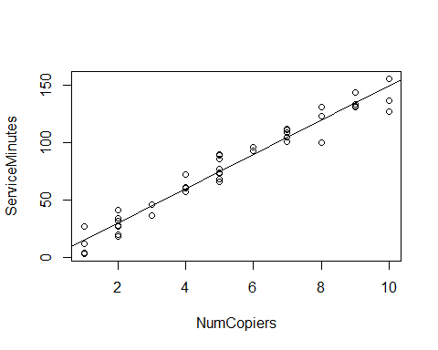

##   
## CONFIDENCE LIMITS FOR INTERCEPT AND SLOPE:

## 5 % 95 %  
## (Intercept) -5.29378 4.133467  
## NumCopiers 14.22314 15.847352

## [1] 1.681071

## [1] 0.01891548

##   
## HYPOTHESIS TESTS FOR INTERCEPT AND SLOPE:

## Estimate Std. Error t value Pr(>|t|)  
## (Intercept) -0.5801567 2.8039411 -0.2069076 8.370587e-01  
## NumCopiers 15.0352480 0.4830872 31.1232581 4.009032e-31

##   
## CONFIDENCE INTERVAL FOR A MEAN RESPONSE at NumCopiers = 6:

## fit lwr upr  
## 1 89.63133 87.28387 91.9788

##   
## PREDICTION INTERVAL FOR AN INDIVIDUAL RESPONSE at NumCopiers = 6:

## fit lwr upr  
## 1 89.63133 74.46433 104.7983

##   
## PREDICTION INTERVAL FOR AN EXPECTED RESPONSE, PER COPIER:

## fit lwr upr  
## 1 14.93856 14.54731 15.3298

##   
## WORKING-HOTELLING CONFIDENCE BAND (LIMITS) at NumCopiers = 6

## fit lower upper  
## 1 89.63133 86.55263 92.71003

##   
## ANOVA TABLE:

## Analysis of Variance Table  
##   
## Response: ServiceMinutes  
## Df Sum Sq Mean Sq F value Pr(>F)   
## NumCopiers 1 76960 76960 968.66 < 2.2e-16 ***  
## Residuals 43 3416 79   
## ---  
## Signif. codes: 0 '***' 0.001 '**' 0.01 '*' 0.05 '.' 0.1 ' ' 1

## DF Sum Sq  
## Corr. Total 44 80376.8

##   
## R SQUARED:

## [1] 0.9574955

##   
## CORRELATION COEFFICIENT:

## [1] 0.978517

Chapter 2 Questions 5(ade) and 14(ab)

2.5) a) First, the t value needs to be calculated with the qt(.95, 43) function. “.95” because for a 90% confidence interval, α = 0.10 and α/2 = 0.05, so for the t test, 1- α/2 = 0.95. The 43 comes from n-2 = 45-2 = 43. qt(.95, 43) = 1.681071. Then from the summary$fit table, we can obtain the standard error for the number of copiers mean estimate is equal to 0.4830872. With these two values, we can then construct a confidence interval by computing 15.0352 ± 1.6811(.4831), which is the slope estimate plus or minus the standard error times qt value. The 90% confidence interval then becomes 14.2231 ≤ β1 ≤ 15.8473 (minutes per copier). This is confirmed by using the confint(fit, level=0.90) command directly.

d) To test whether the mean required time increases by more than 14 minutes for each additional copier that is serviced, I conducted a t test. The alternatives are *H0: β1 ≤ 14* and *Ha: β1 > 14.* To find t*, I did (15.0352 – 14 minutes)/0.4830872 which = 2.1428. The decision rule states if |t*| ≤ 1.681071 (from qt() function from part (a)) then conclude *H0*, and if |t*|> 1.681071, then confirm *Ha* . Since |t*| = 2.1428, I concluded *Ha* . The risk of a Type I error was set at 0.05. To calculate the P value of this test, I used the pt(2.1428, 43, lower=FALSE) command and obtained 0.01891548 = P-value.

e) In this example, *β0* = -0.5802. This intercept does not really give any relevant information about the start-up time of calls since it is a negative value. A t-test on the hypothesis that *H0* = 0 would probably show insignificant evidence to reject that *β0* = 0 , meaning that the actual *β0* value does not significantly vary from *β0* = 0.

14) a) A 90 percent confidence interval for the mean service time on calls in which six copiers are serviced is found with the predict function, number of copiers set to 6, and the interval set to “confidence”. The resulting values are 89.63133, 87.28387, 91.9788. This means that the estimated Ŷ6 = 89.63 and the 90 percent confidence interval being 87.28387 ≤ Ŷ6 ≥ 91.9788 (minutes). This also could have been computed using the qt() value, the estimated slope, and the standard error.

b) A 90 percent prediction interval for the mean service time on the next call in which six copiers are serviced is found with the predict function, number of copiers set to 6, and the interval set to “prediction”. The resulting values are 89.63133, 74.46433, 104.7983. This means that the prediction for the next call with six copiers needing service is predicted to take 89.63133 minutes, the same as the confidence estimate in part (a). The 90 percent prediction interval however, is 74.46433 ≤ Ŷ6 (new) ≥ 104.7983 (minutes). This prediction interval IS wider than the confidence interval because the confidence interval is based on a mean value, which is always more accurate than an estimate of a single new data point.